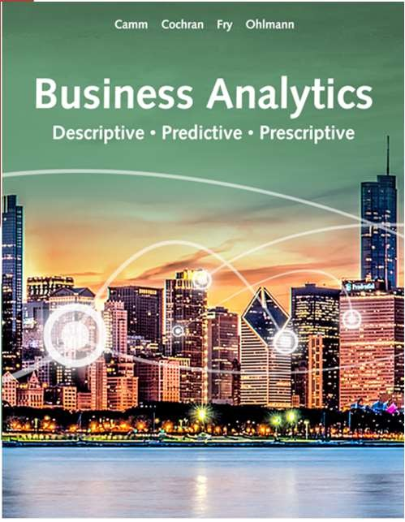

Business Analytics

Chapter 10 – Some Useful Functions for Modeling

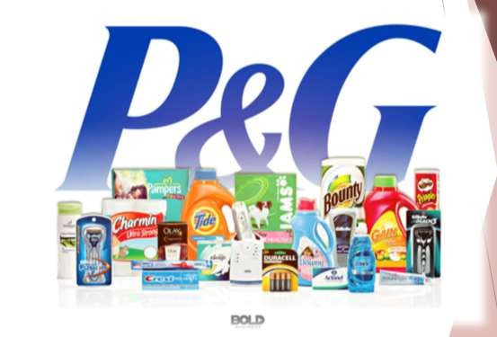

Introduction

◆ Procter & Gamble

◆ Fortune 500 consumer good company

◆ Excellence in Business Analytics

◆ Must maintain inventory around the world.

◆ Not enough?

◆ Too much?

◆ Solution: Spreadsheet Models

◆ When and how much inventory to order

70% of P & G companies use these models 10% reduction in inventory

= $350 million in savings



Introduction

◆ What-if Analysis (Using Spreadsheet Models)

◆ Provide easy-to-use, sophisticated mathematical and logical functions.

◆ Allow for easy instantaneous recalculation for a change in model inputs.

◆ Are fairly easy to use.

◆ The most used business analytics tool.

◆ Answer Questions Like:

◆ If the per unit cost is $4 what is the impact on profit?

◆ May help you with your final projects!



Spread Sheet Models or What-If Analysis Tools

Data Tables Goal Seek

Scenario Manager

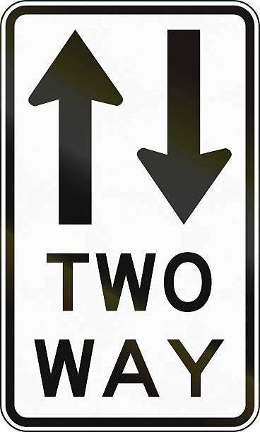

What-If Analysis

◆ **Data Tables:**

◆ Excel tool which quantifies the impact of changing the value of a specific input on an output of interest.

**One-way data table:**

Summarizes a single input’s impact on the output.

**Two-way data table:** Summarizes two inputs’ impact on the output.

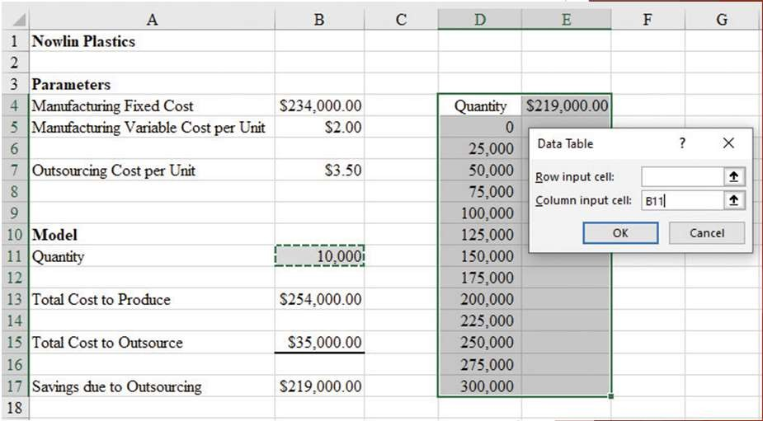

What-If Analysis

Figure 10.4: The Input for Constructing a One-Way Data Table for Nowlin Plastics

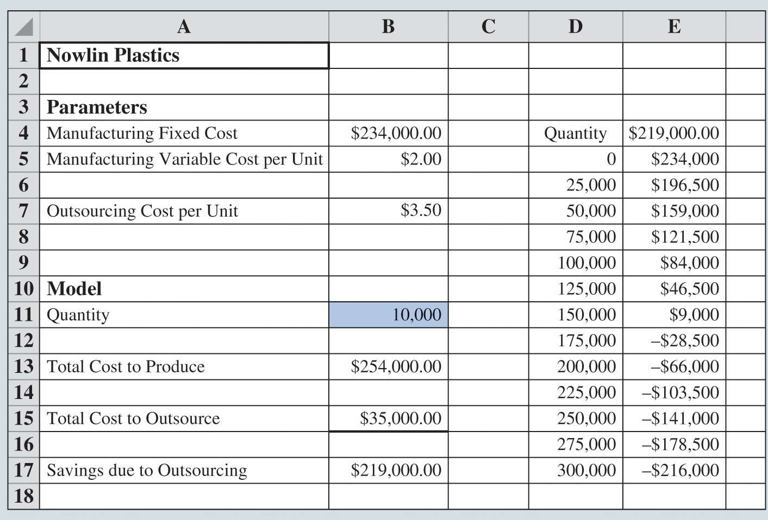

What-If Analysis

Figure 10.5 Results of One- Way Data Table for Nowlin Plastics

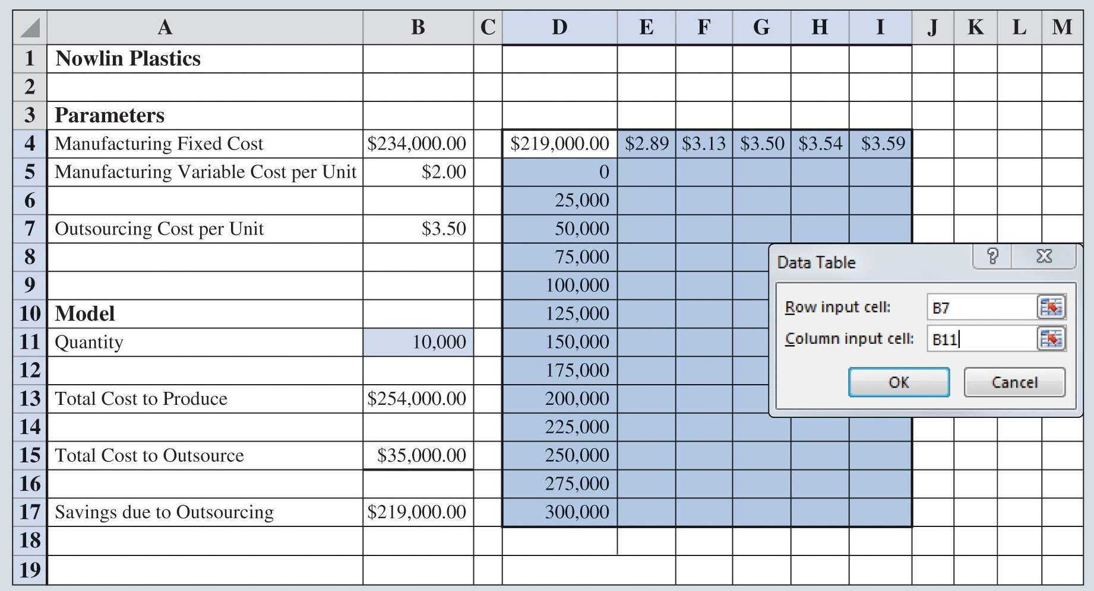

What-If Analysis

Figure 10.6: The Input for Constructing a Two- Way Data table for Nowlin Plastics

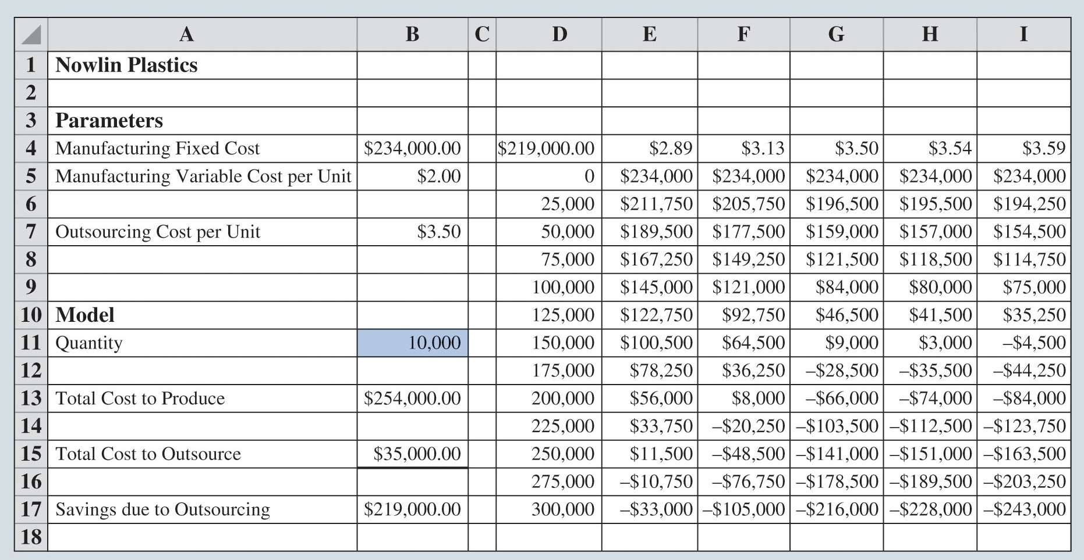

What-If Analysis

Figure 10.7: Results of Two-Way Data Table for Nowlin Plastics



What-If Analysis

◆ **Goal Seek:**

◆ Excel tool that allows the user to determine the value of an input cell that will cause the value of a related output cell to equal some specified value (the goal).

◆ In the case of Nowlin Plastics:

◆ Suppose we want to know the value of the quantity of phone cases where it becomes more cost effective to manufacture rather than outsource.

◆ Goal Seek will tell us!

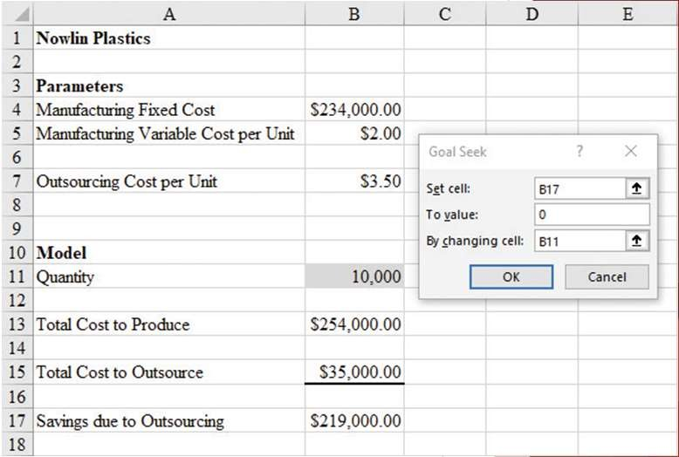

What-If Analysis

Figure 10.8: Goal Seek Dialog Box for Nowlin Plastics

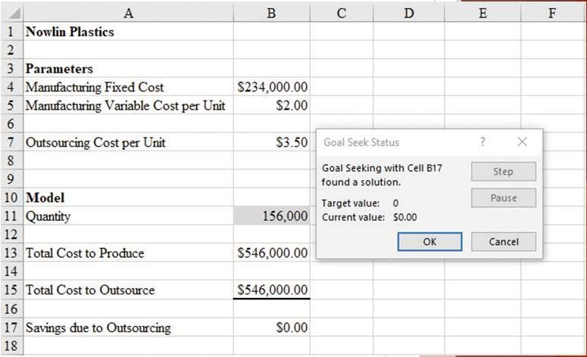

What-If Analysis

Figure 10.9: Results from Goal Seek for Nowlin Plastics



What-If Analysis

◆ **Scenario Manager:**

◆ Excel tool that quantifies the impact of changing multiple inputs on one or more outputs of interest.

◆ Scenario Manager extends the data table concept to cases:

◆ When you are interested in changing more than two inputs

◆ When you want to quantify the changes these inputs have on one or more outputs of interest.



Middletown Amusement Park

◆ Season Pass:

◆ Annual Membership

◆ No cost at gate

◆ $15 per person on food etc.

◆ No Season Pass

◆ $35 at gate

◆ $45 per person on food etc.

◆ Cost of Operations $33,000

◆ Cost of goods = 50% price of good



Middletown Amusement Park

◆ Profit:

◆ Dependent on Weather!

◆ Scenarios:

◆ 1. Partly Cloudy

◆ 2. Rain

◆ 3. Sunny

◆ Inputs Effected

◆ Number of people in the park

◆ $ spent on food etc.

◆ Cost of operations

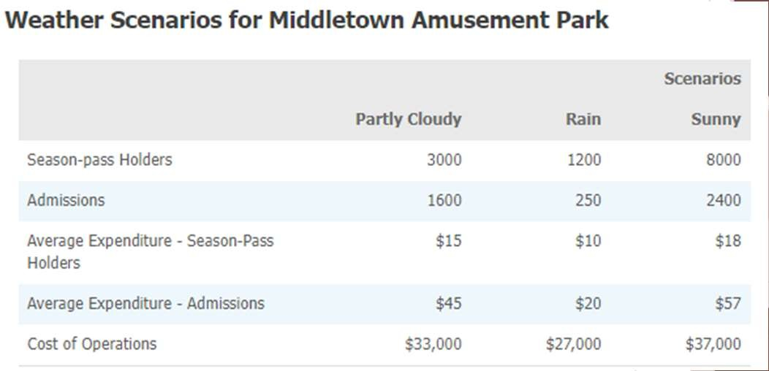

Middletown Amusement Park

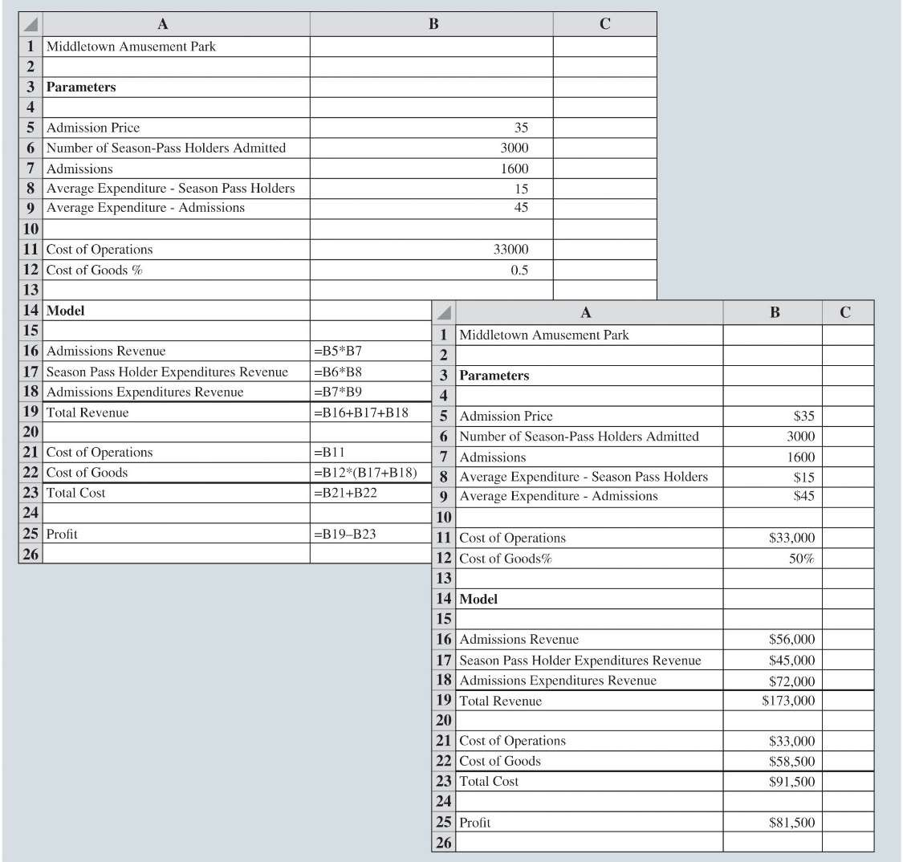

What-If Analysis

Figure 10.10: Middletown Amusement Park Daily Profit Model

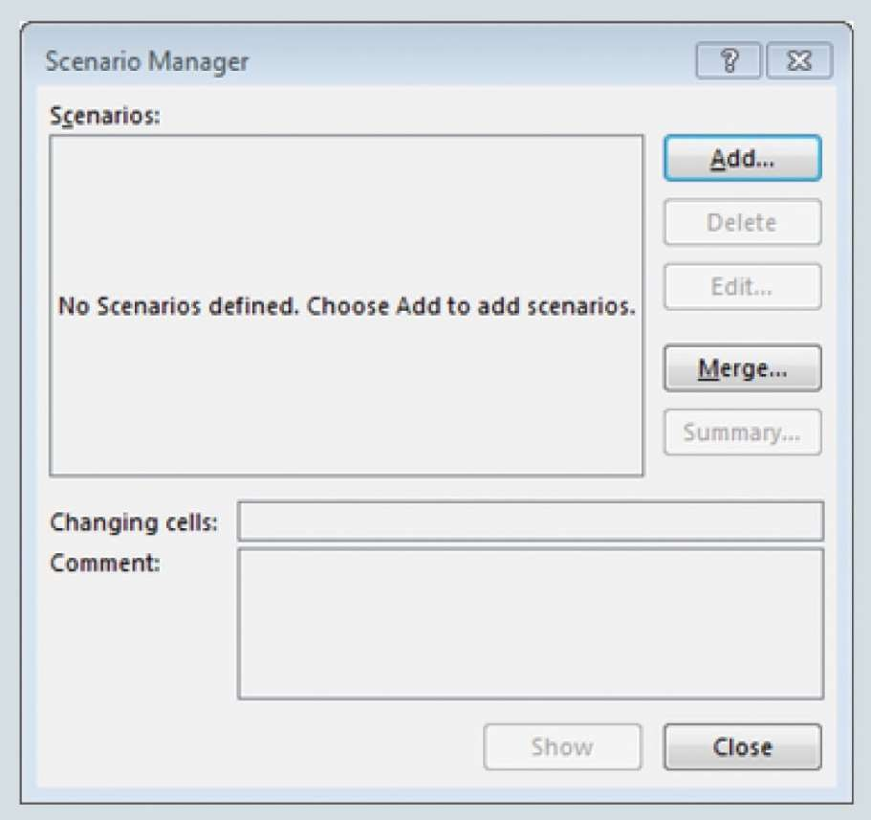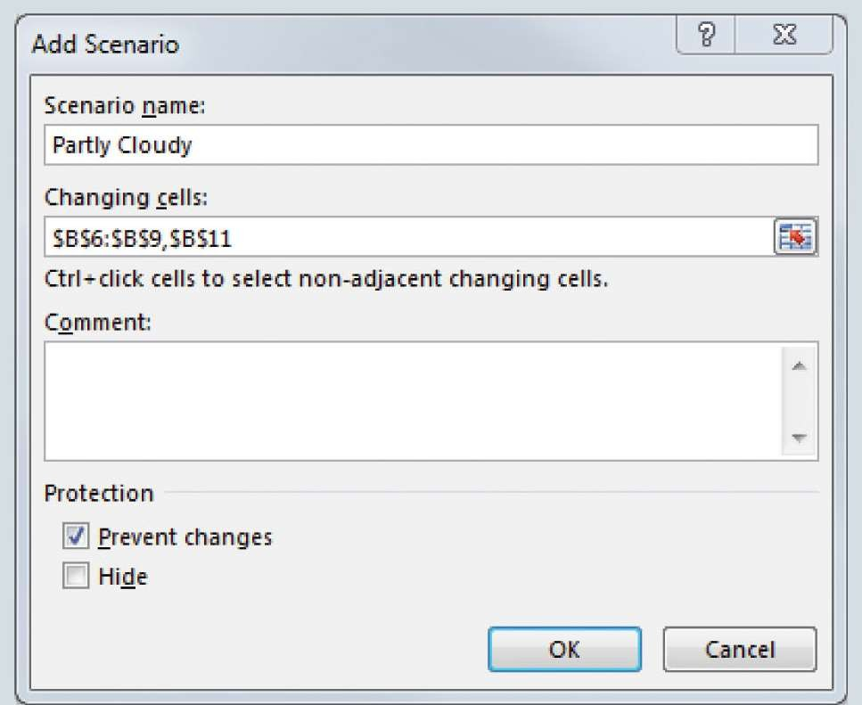

What-If Analysis

Figure 10.11: Scenario Manager Dialog Box

Figure 10.12:

Add Scenario Dialog Box

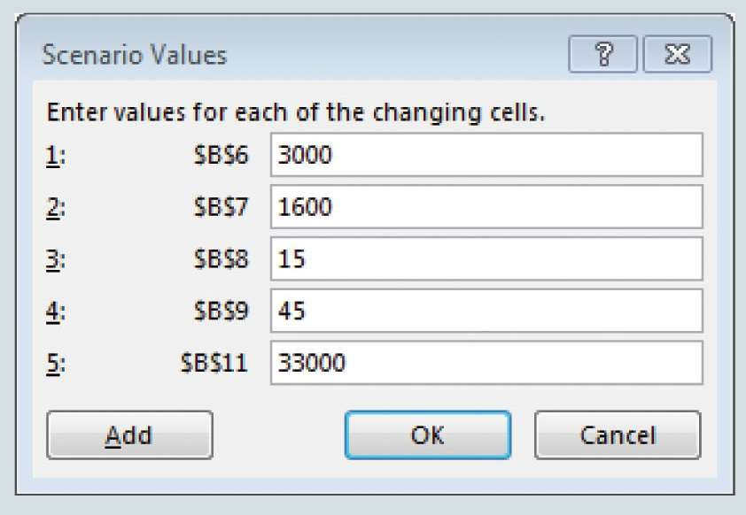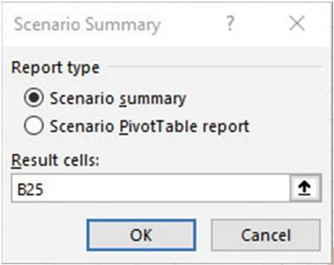

What-If Analysis

Figure 10.13: Scenario Values Dialog Box

Figure 10.14: Scenario Summary Dialog Box

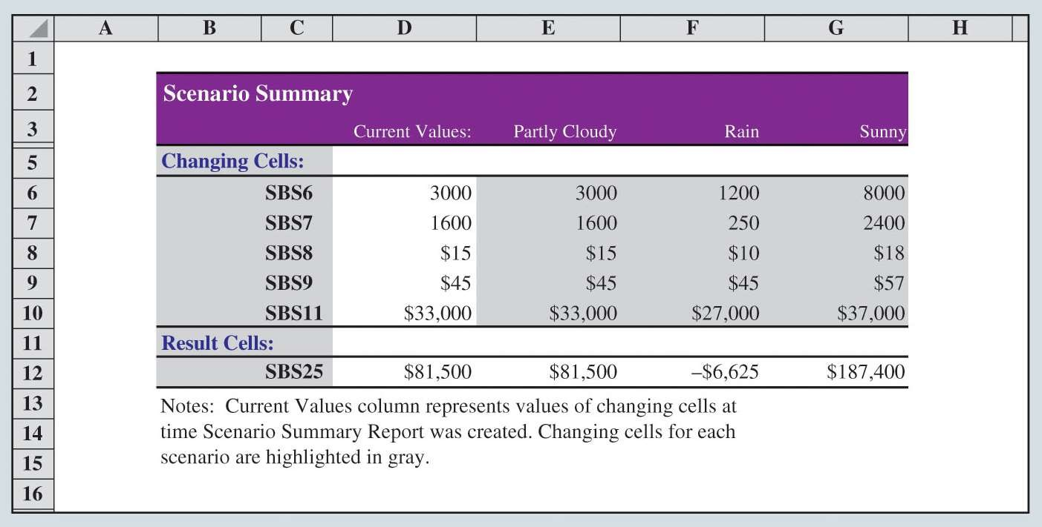

What-If Analysis

Figure 10.15: Scenario Summary for Middletown Amusement Park